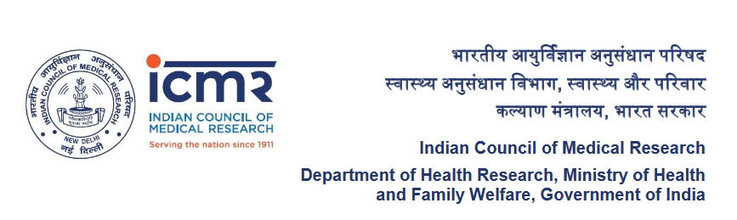

List of Codal documents for
Research Associate (RA) proposals

Sno | List of Documents
1 | *Declaration & Attestation Form (duly signed by Head of Department/ Director)
2 | * All Certificates of Educational qualifications12th onwards to your highest qualification 12th onwards to Ph.D/MD/MS/MDS OR equivalent degree OR having 3 years of research teaching and design and development experience after MVSc./MPharma/ME/M.Tech  Note: Merge all documents and upload single PDF file
3 | *Proof of Date of Birth
4 | *Details of Guide
5 | *Research Experience of Fellow
6 | *Availability of Institutional facilities signed by Guide and counter signed by Head of the Institute with seal
7 | *Scientific and Industrial Research Organisation (SIRO) OR Department of Scientific and Industrial Research (DSIR) Certificate
8 | *Science Citation Index (SCI) Journal Article published by applicant
9 | Institutional Animal Ethics Committee (if applicable)
10 | Case record proforma, study instruments, questionnaires, scales, etc
11 | Drugs Controller General of India (DCGI) Approval (if applicable)
12 | Institutional Ethics Committee (undertaking for non requirement of ethics approval whichever appropriate)
13 | Institutional Committee for Stem Cell Research (if applicable)
14 | Institutional Bio-safety Committee (if applicable)
15 | Review Committee on Genetic Manipulation (RDNAT)- Recombinant DNA technology (if applicable)
16 | Mandate Form (duly signed by account officer)
17 | Informed Consent Form (if applicable)

